Risk Management in Logistics: research metrics and trends

This study intends to perform a bibliometric approach to assert the metrics and research trends in the field of Risk Management in Logistics. This paper analyzed scientific articles according to common words, date, countries, authors and references. The MetrIA software allowed the modelling of data and the generation of graphs from a dataset of results obtained in a query on Elsevier’s Scopus.

The analysis of the scientific production on Risk Management in Logistics provided a portrait of what are the interests of different countries about the area – as well, how this interest changed over time.

**Introduction**

Given the development of the Logistics sector and Risk Management activities in the modern world – mainly for the intense trade between nations, the rise of e-commerce, greater quality and speed requirements from clients and the development of management tools and methods some questions emerge: how large is the scientific interest in the area? In what direction is this interest developing over time and which countries are performing research in the field?

The interest of researchers can be portrayed by scientific publications, as publishing articles in an expression of their work. The analysis of peer-reviewed articles also provide quality-control about the produced works, making sure that the information is objective, precise and that it is share in a properly-themed journal. According to Okubo (1997), tracking publications is an effective method to assert the developing of knowledge, because there are a number of factors that push researchers into publishing: by performing this act, researchers are protecting the intellectual property of their work, as claims of ownership of an idea can be laid on those that published it (Okubo, 1997). Also, researchers are compelled to publish by their institutions, thus sharing the information with other scientists and promoting advances in the studied field. The author also points out that there is a social factor: personal recognition in the scientific community.

One of the ways to analyze such interest is to study the corpus of scientific texts using bibliometric analysis. Bibliometrics, as define by Okubo (1997), is “tool by which the state of science and technology can be observed through the overall production of scientific literature”. This kind of analysis allows to look at a macro levels (countries, fields of research, institutions, networks of publishers) and micro levels (a specific publication in a given year, a single author, etc.).

According to Moed et al. (2004), the advantages of this kind of analysis is to overcome some of the limitations provided the peer review process:

(…) peer review may have serious shortcomings and disadvantages. Subjectivity, i.e. dependence of the outcomes on the choice of individual committee members, is one of the major problems. This dependence may result in conflicts of interests, unawareness of quality or a negative bias against younger people or newcomers to the field. To make peer review more objective and transparent, it should be supported by advanced bibliometric methods.

Okubo (idem) also highlights that kind of analysis allows the assess the state that science has achieved at that moment, aiding in decisions making for policies in the relative areas of study.

Bibliometric alone is not enough to justify a decision or replace an expert in a given field, according to Okubo (idem). These indicators should be employed alongside other tools, or order to provide a glance of a field.

Citations are a usual metric in bibliometrics, because they provide some insights into the origins of the information that is contained in the article.

Citations are a measure of the overall impact of an article’s influence, or that of its authors, on the scientific community; they are a complex socio-epistemological parameter which probably induces a quality factor, but this factor is neither equivalent to, nor unequivocally correlated with, scientific quality (Seglen, 1992).

There are some points that require the attention of researchers when dealing with metrics based on citations: some citations are negative (discrediting work), not endorsements. A

The Measurement of Science

One of the main breakthroughs (Wouters, 1999) was the area of bibliometrics was the creation of the Science Citation Index, as it stabilished the grounds for whole branches of science to perform statistical analisys of scientific production to create indicators of scientific production.

MEASURING SCIENCE

Anthony F.J. van Raan

Centre for Science and Technology Studies (CWTS), Leiden University, the Netherlands

‘How many researchers? How much money is spent on science? How ‘good’

are research groups? How does communication in science work, particularly

what is the role of books, journals, conferences (Borgman, 1990)?

But

These questions do not address these other points:

How do scientists decide what will be

called a scientific fact? How do scientists decide whether a particular

observation supports or contradicts a theory? How do scientists come to

accept certain methods or scientific instruments as valid means of attaining

knowledge? How does knowledge selectively accumulate? (Cole et al.,

1978).

Some of the main indicators provided by the SCI every year the ranking of articles published by country and by institutional. The first is used to demonstrate scientific output and national wealth of a nation. The second is used to point which institutions have more prestige.

“A numerical indicator or an indicative pattern, standing alone, has little significance. The data must be given perspective: the change of an indicator with time, or different rates of change of two different indicators.” Anthony F.J. van Raan

Raan points that “electrical power consumption in kilowatthours,

indicating that scientific power, economic power, and national wealth

are strongly related”

**The Metria software**

As the data provided by Scopus did not provide enough details about the existing relationships in the dataset, nor additional details about the references contained in the report, this study employed a specialist software named Metria. The software allows to perform Natural Language Processing tasks in different groups of text (de Stefano, 2016). As the data exported by Scopus contains the abstract of each article, it was possible to have a graphical representation of the content produced in the database by location and date. The graphs were rendered in the Gephi[1] software using csv files generated by Metria using the data provided by Scopus.

**The Scopus database**

To obtain large amount of scientific articles is a challenging task – a researcher interested into doing so needs to confront multiple systems that catalogue their content without following a standard, creating difficulties to parsing the information. Also, given the amount of scientific articles that are published every year, having the infrastructure to download and store large datasets of information – and the computational power to process them – requires expansive investment.

In order to allow the access to an expressive number of articles, the researchers of this study chose to employ the Scopus database. Scopus presents itself as a bibliographic database with abstracts and citations from scientific articles. As of January 2017, According to its webpage, the database claims to contain 22,000 publications from 5,000 different publishers.[2]

The access to the database was provided by Portal Capes[3], a web proxy provided by the Brazilian Government to access subscribed scientific publications.

This study chose the Scopus database because of the size of its catalogue and because of its ease of use – as it allows exporting query results into Comma Separated Value (CSV) files and then to model the data into other software.

**Methodology**

The results presented in this study can be replicated and adjusted with other parameters according to the liking of the researcher. The Metria tools to model the data are also have open source code, allowing additional customization of results.

The first step was to access the Scopus database homepage and query the following parameters: Risk Management AND logistics. The “AND” keyword is a logic operator to ensure that results will contain the expression “Risk Management” and “logistics”.

The database provides around 12 thousand results for this query. As the concept of Risk Management and Logistics can be employed into different areas of study, adding a filter is required: limit the results to the Business, Management and Accounting area. This filter reduced the number of results to 613 items. As this study intended to list the main references of each year since 2006, the results from the year 2017 were excluded from the query, as this year was not finished until the submitting of this study.

Scopus provides some built-in tools to verify some insights about the queried data: authors, journals and countries listed by publication. Some of these results were also put into context in this study.

To perform additional analyses, the query results were exported to a CSV file (by checking the “export all available information” option).

Some tools from MetrIA are employed to parse the exported data – these are contained in the “scopus-browser” module, available in the GitHub[4] website.

Two scripts developed in JavaScript are employed in this study: parse-csv and csv-to-Gephi.

The parse-csv script lists and counts the occurrences of all references of the results. The objective of this analysis is to verify what are the main sources of information in the corpus.

**Risk Management research**

Both logistics and risk management are ancient techniques that have been the point of interest of merchants, governments and military leaders through the ages. The earliest forms of insurance can be traced by the Chinese and Babylonian societies, going as far as the 3rd and 2nd millennia BC. Chinese merchants would split goods between different vessels to reduce the risk of losing cargo if one of the ships would sink.

The oldest registered law code, the Code of Hammurabi (created at 1750 BC), shows the practice of insurance: if a merchant acquired a loan to transport goods, he could pay an additional sum to the lender to allow the cancellation of the loan if the cargo was lost at sea or stolen.

The study of risk management began after World War II. Risk management has long been associated with the use of market insurance to protect individuals and companies from various losses associated with accidents. Other forms of risk management, alternatives to market insurance, surfaced during the 1950s when market insurance was perceived as very costly and incomplete for protection against pure risk. The use of derivatives as risk management instruments arose during the 1970s, and expanded rapidly during the 1980s, as companies intensified their financial risk management. International risk regulation began in the 1980s, and financial firms developed internal risk management models and capital calculation formulas to hedge against unanticipated risks and reduce regulatory capital. Concomitantly, governance of risk management became essential, integrated risk management was introduced, and the chief risk officer positions were created. Nonetheless, these regulations, governance rules, and risk management methods failed to prevent the financial crisis that began in 2007. [2]

Traditional publications use a structure based on issues and volumes to deliver content. It is possible to group

With the

Following are the methods used to replicate these results. Other researchers can change the parameters according to their criteria to perform new analisys and get insights.

The methodology can be replicated

http://citeseerx.ist.psu.edu/viewdoc/download?doi=10.1.1.458.6543&rep=rep1&type=pdf

Risk Analysis and Risk Management: An Historical Perspective

<http://onlinelibrary.wiley.com/doi/10.1111/j.1539-6924.1985.tb00159.x/full>

1. Okubo Y. Bibliometric indicators and analysis of research systems: methods and examples. Paris: OCDE; 1997.

The 20 most common references found in the analyzed texts were:

|  |  |  |  |  |  |
| --- | --- | --- | --- | --- | --- |
| Title | Count | Country | Journal | Year |  |
| Managing Disruption Risks in Supply Chains | 11 | USA | Production and Operations Management | 2005 |  |
| Mitigating supply chain risk through improved confidence | 8 | UK | International Journal of Physical Distribution & Logistics Management | 2006 |  |
| On the value of mitigation and contingency strategies for managing supply chain disruption risks | 8 | USA | Management Science | 2006 |  |
| Using agency theory to design successful outsourcing relationships | 7 | UK | International Journal of Logistics Management | 2000 |  |
| Perspectives in supply chain risk management | 7 | USA | International Journal of Logistics Management | 2006 |  |
| An empirical analysis of the effect of supply chain disruptions on long-run stock price performance and equity risk of the firm | 6 | USA | Production and Operations Management | 2005 |  |
| A supply chain view of the resilient enterprise | 6 | USA | MIT Sloan Management Review | 2005 |  |
| An empirical examination of supply chain performance along several dimensions of risk | 6 | Germany | Journal of Business Logistics | 2008 |  |
| Proactive planning for catastrophic events in supply chains | 5 | USA | Journal of Operations Management | 2009 |  |
| Building the resilient supply chain | 5 | UK | International Journal of Logistics Management | 2004 |  |
| The effect of supply chain glitches on shareholder wealth | 5 | USA | Journal of Operations Management | 2003 |  |
| Supply chain risks: A review and typology | 5 | USA | International Journal of Logistics Management | 2009 |  |
| Third party logistics: A literature review and research agenda | 5 | UK | International Journal of Logistics Management | 2007 |  |
| The severity of supply chain disruptions: Design characteristics and mitigation capabilities | 5 | USA | Decision Sciences | 2007 |  |
| Aligning supply chain strategies with product uncertainties | 5 | USA | California Management Review | 2002 |  |
| Approaches to managing global sourcing risk | 4 | UK, Turkey | Supply Chain Management: An International Journal | 2011 |  |
| Defining supply chain management | 4 | USA | Journal of Business Logistics | 2001 |  |
| Ericsson's proactive supply chain risk management approach after a serious sub-supplier accident | 4 | Sweden | International Journal of Physical Distribution & Logistics Management | 2004 |  |
| An empirical investigation into supply chain vulnerability | 4 | Germany | Journal of Purchasing and Supply Management | 2006 |  |

It is worth to note that as the analyzed texts where from the 1975 to 2016 period, texts from the last years had a lower chance of being referred, creating a bias towards the counting of texts from earlier years.

In order to turn the abstracts into a graph file, some data processing was required.

The data provided by Scopus comes uses the following structure:

|  |  |  |  |  |
| --- | --- | --- | --- | --- |
| Authors | Title | ... | Abstract |  |
| Yoon J., Yildiz H., Talluri S.S. | Risk Management Strategies in Transportation Capacity (…) | ... | Risk Management Strategies (…) |  |
| … | … | ... | … |  |

In order to generate a graph, we need two files: one for nodes and another one for edges.

Nodes represent each individual item in the graph. Edges represent the connection between two nodes, and their strength (called “weight” in graph terms). The nodes

|  |  |
| --- | --- |
| ID | Label |
| 1 | Management |
| 2 | Control |
| … | … |

The edges file represents the connection between two nodes. To do so, the file specifies a source id and a target id and if the connection is directed or undirected. A directed graph the source references the target; in the undirected, both are referencing each other. In order to reference these nodes, we need to use their ids. An edge file uses the following structure:

|  |  |  |
| --- | --- | --- |
| source | target | Type |
| 1 | 2 | Undirected |
| 1 | 31 | Undirected |
| 2 | 12 | Undirected |
| … | … | … |

After downloading the data, the researchers from this study used a tool from the software Metria to export the abstracts of the analysed articles

Publications by country in the last 10 years

|  |  |  |  |  |  |  |  |  |  |  |  |
| --- | --- | --- | --- | --- | --- | --- | --- | --- | --- | --- | --- |
| Country | 2006 | 2007 | 2008 | 2009 | 2010 | 2011 | 2012 | 2013 | 2014 | 2015 | 2016 |
| China | 1 | 2 | 24 | 13 | 85 | 19 | 2 | 3 | 8 | 3 | 5 |
| USA | 3 | 6 | 5 | 12 | 8 | 5 | 10 | 6 | 9 | 8 | 8 |
| UK | 1 | 1 |  | 3 | 6 | 2 |  | 5 | 3 | 4 | 4 |
| Germany |  |  | 3 | 1 | 2 | 2 | 2 | 2 | 4 | 2 | 1 |
| Australia |  |  | 1 | 3 | 1 |  | 2 | 2 |  | 6 | 1 |
| Hong Kong |  |  | 2 | 1 | 3 | 1 | 1 | 2 |  | 3 |  |
| India | 1 |  | 1 |  | 2 |  | 2 | 2 |  | 1 | 4 |
| Italy | 1 |  |  | 2 | 1 | 1 | 1 | 2 | 1 | 2 | 2 |
| Sweden |  |  |  | 1 | 1 | 2 | 3 |  | 3 | 2 |  |

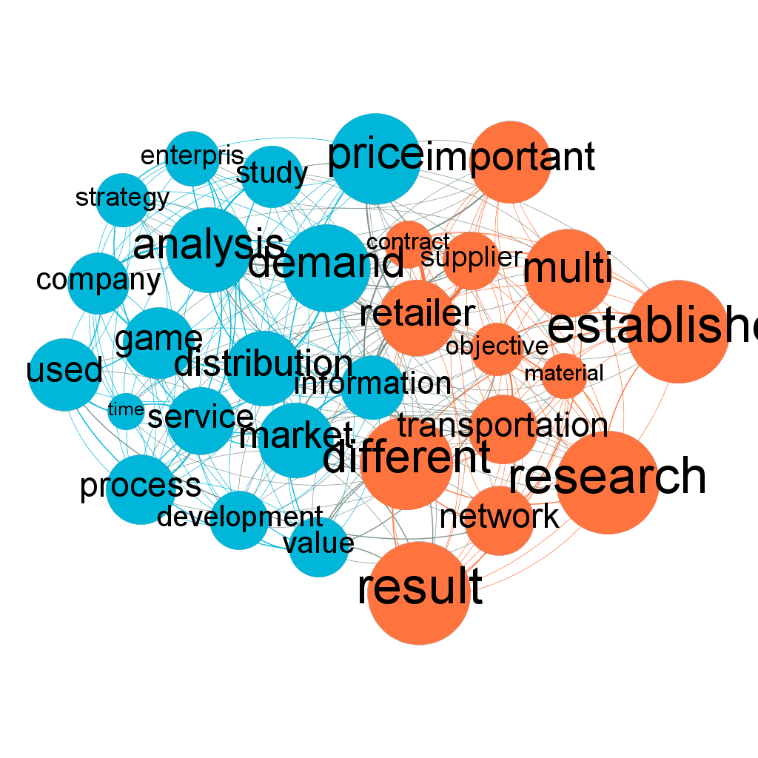

Figure - China

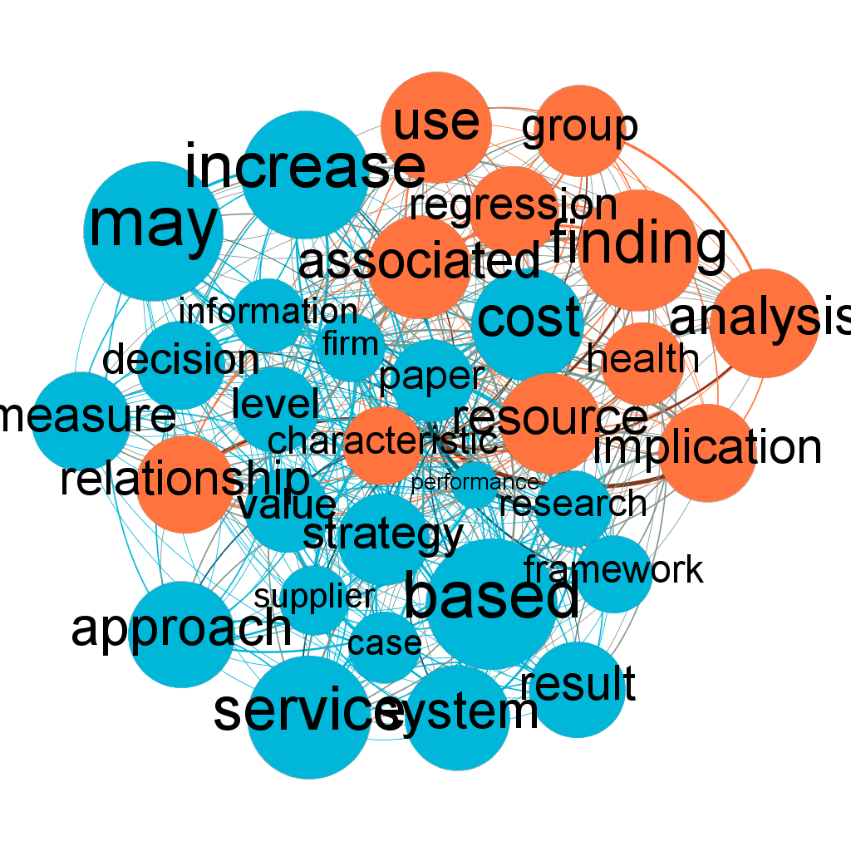

In the graph for research articles authored in the United States it is possible to note that the expression “may increase” has been used frequently in the abstracts. The expression has a relation with the terms “information” and “decision”, which points that articles search for methods that may increase (production, speed, profit) based on information. It is also possible to note that the term “relationship” is present, as managing human relations might be a

The presence of the term “service” shows that Logistics can be seen a service

management Timebased competition The concept of leadtime Logistics pipeline managementReducing logistics ... logic The trend to 'servitisation' Implications of servitisation for logistics The critical role ... chain processes Managing the service supply chain 12 Managing risk in the

Figura - United States

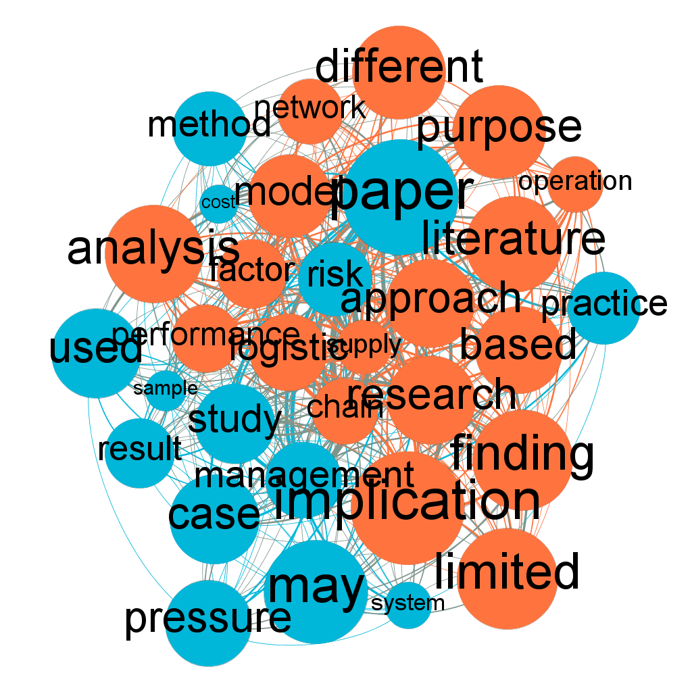

Australia

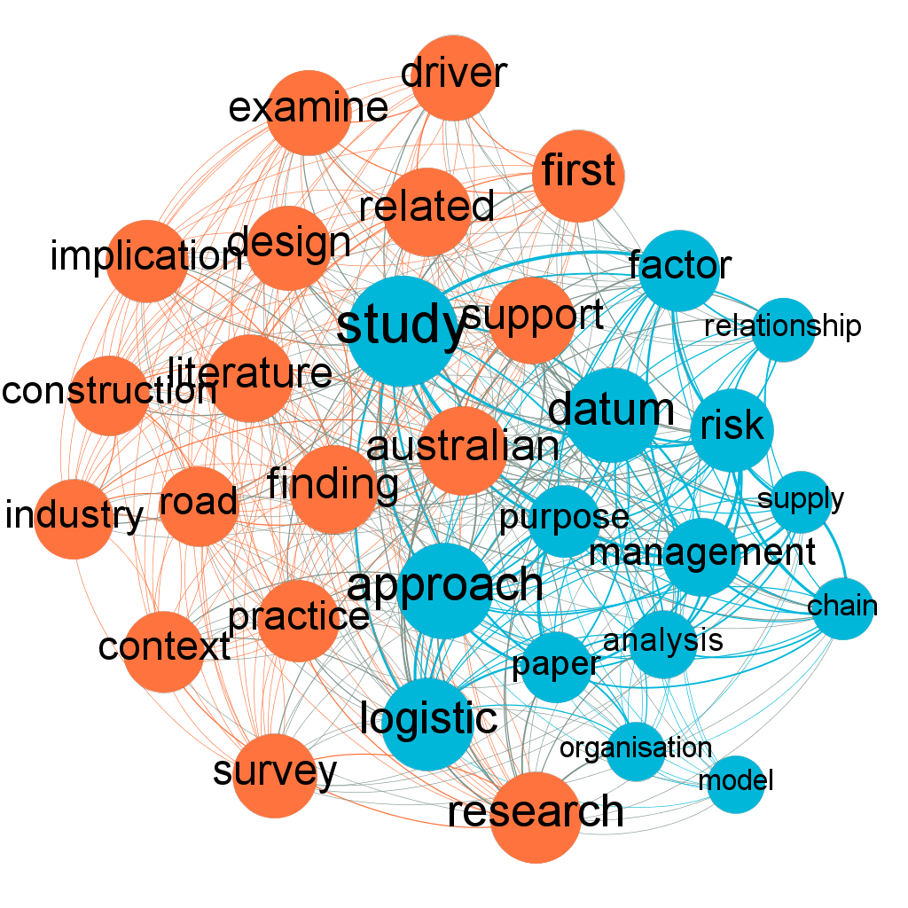

India

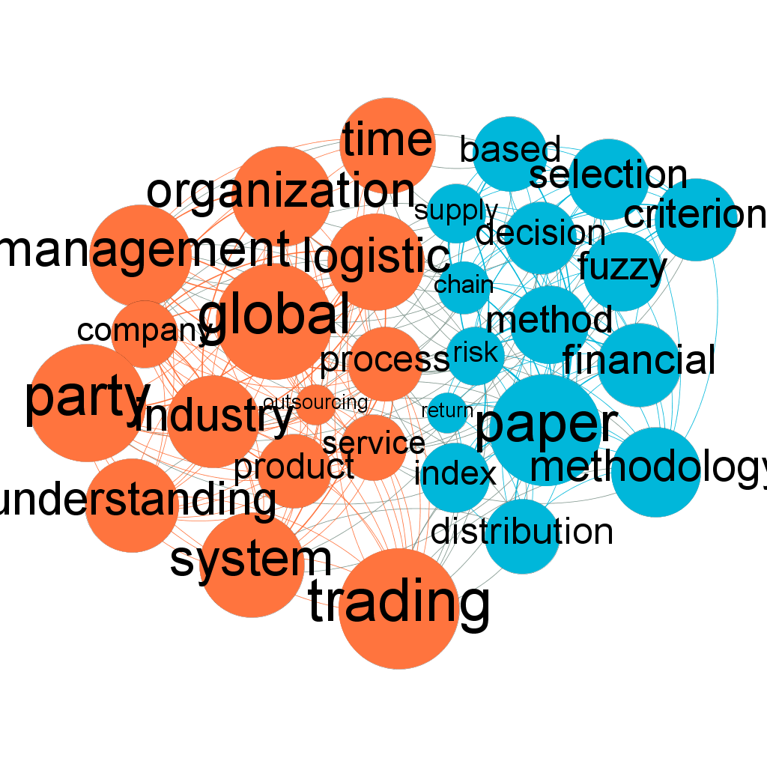

Germany

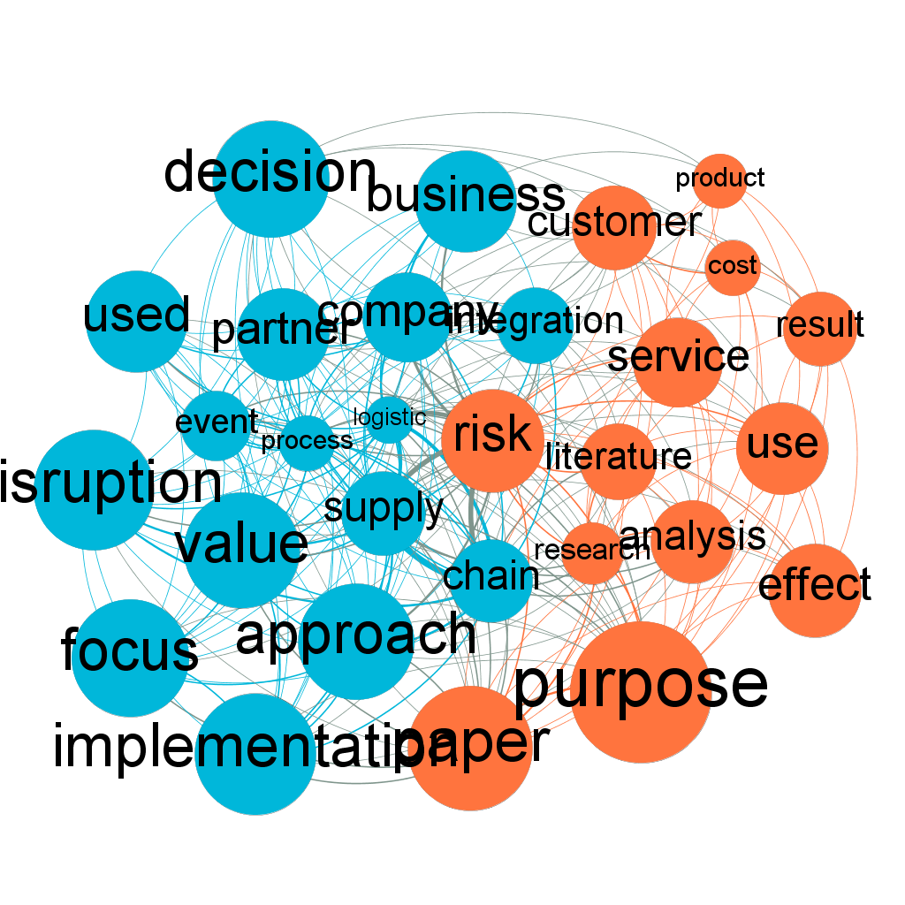

Sweden

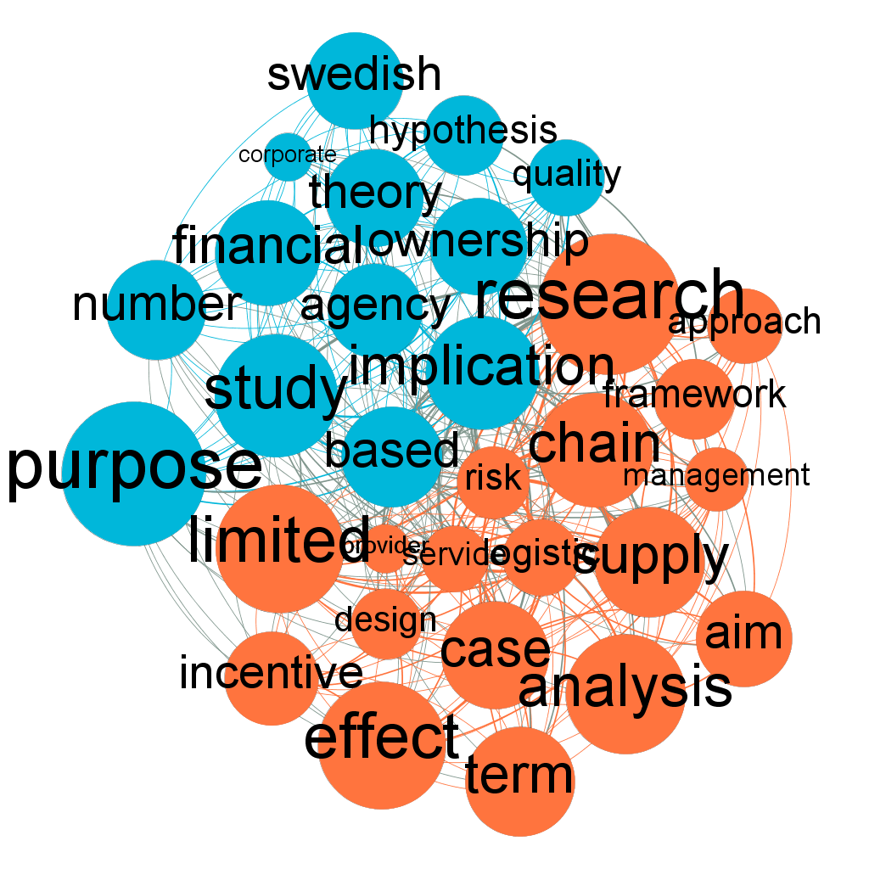

Hong Kong

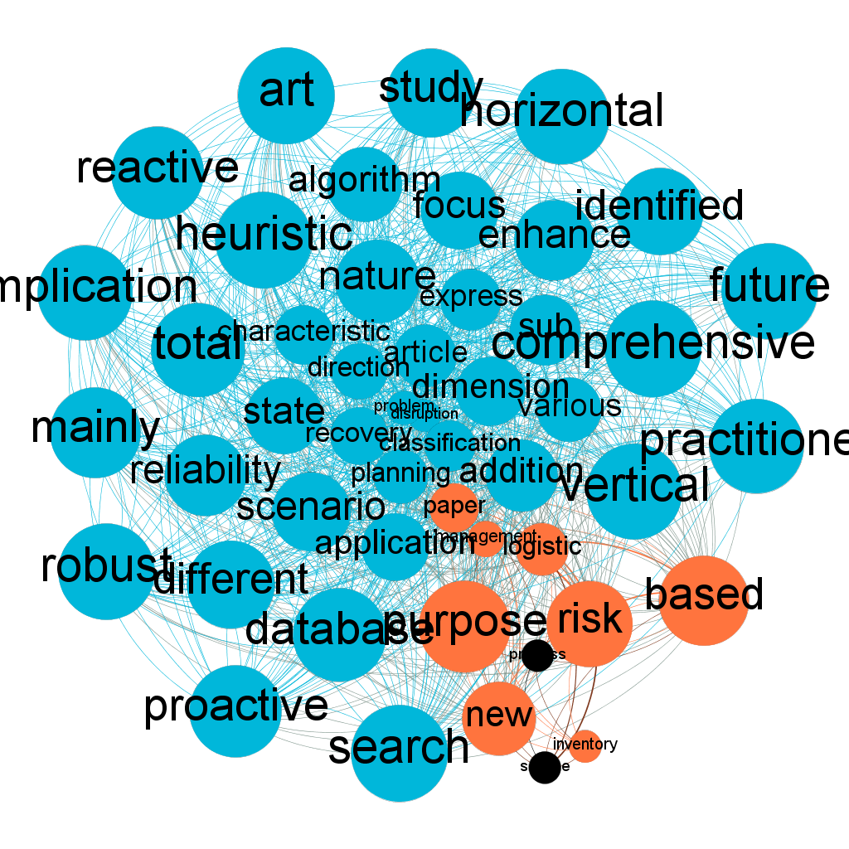

**Results**

**References**

J.Tepic, I.Tanackov, S.Gordan, ANCIENT LOGISTICS – HISTORICAL TIMELINE AND ETYMOLOGY, Technical Gazette 18, 2011 <http://connection.ebscohost.com/c/articles/67363071/ancient-logistics-historical-timeline-etymology>

de Stefano, E., de Sequeira Santos, M.P. & Balassiano, R. Scientometrics (2016) 109: 1579. doi:10.1007/s11192-016-2152-6 Available at http://rd.springer.com/article/10.1007/s11192-016-2152-6

[2] Dionne, Georges, Risk Management: History, Definition, and Critique (Fall 2013). Risk Management and Insurance Review, Vol. 16, Issue 2, pp. 147-166, 2013. Available at SSRN: <https://ssrn.com/abstract=2355586> or <http://dx.doi.org/10.1111/rmir.12016>

https://papers.ssrn.com/sol3/papers.cfm?abstract_id=2355586

GIAGLIS, G. M. et al. Minimizing logistics risk through real‐time vehicle routing and mobile technologies. International Journal of Physical Distribution & Logistics Management, v. 34, n. 9, p. 749–764, out. 2004.

Okubo, Y. (1997), “Bibliometric Indicators and Analysis of Research Systems: Methods and Examples”, OECD Science, Technology and Industry Working Papers, 1997/01, OECD Publishing, Paris. <http://dx.doi.org/10.1787/208277770603>

H. F. Moed, W. Glänzel, & U. Schmoch (Eds.), Handbook of quantitative science and technology research (pp. 187–213). Dordrecht: Kluwer Academic Publishers.

1. Referencia para o gephi
2. http://www.elsevier.com/online-tools/scopus/content-overview
3. Link para o portal capes
4. Link para ao código fonte (vai contar como duas referencias + projeto open source para o lattes)